How to care for books borrowed from the

Lakeview Elementary Library

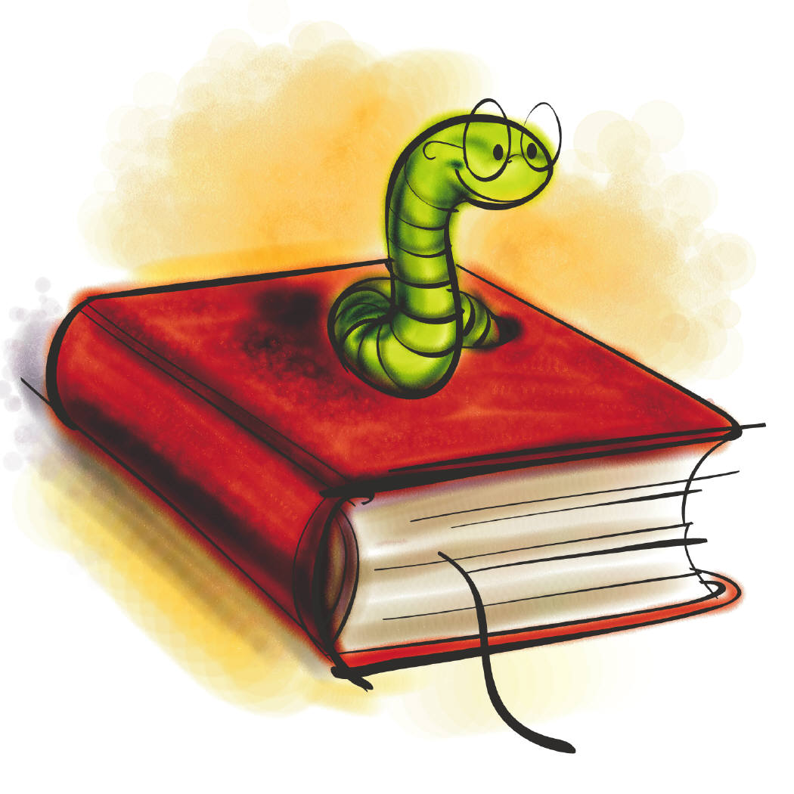
- Remember to have clean hands when reading books, to use a bookmark, and to turn the pages carefully from the upper right hand corner.
- Find a good, well-lighted place to read and find a place for your library book that is out of reach of pets or little brothers and sisters. (Pets like to chew and little ones like to color).
- Return your books on time. Your book is due the next time you visit our library (two weeks if you are in Third Grade). Your library day will be the same each week so make a note of it.

- If it is raining please, protect your book by placing it in a plastic bag.
- Do not put books in backpacks with your lunch. The books can take on a food smell and drinks will destroy a book.

- Do not write in your book, tear or bend the pages and please do not eat or drink while reading. If you lose or damage your book, you or your parents will have to pay for it even if the damage is accidental. You will not be able to check out a new book until the lost or damaged book is paid for.

- Please do not try to mend library books at home. Send damaged books to school for repair.

- If you notice damage in a book, please let Mrs. McKinney know about it.

- Most importantly, PLEASE HAVE FUN READING!

